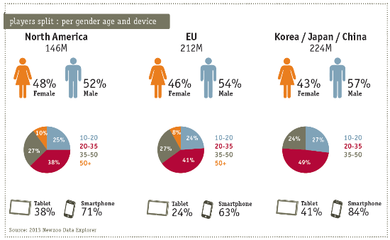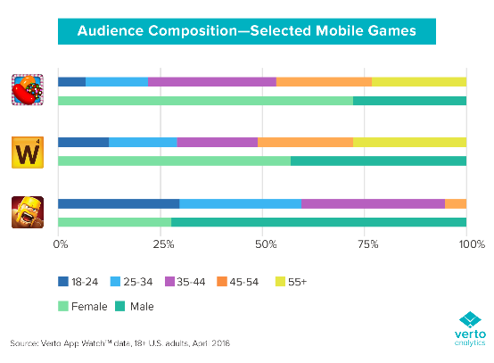**The demographics of mobile based app games**

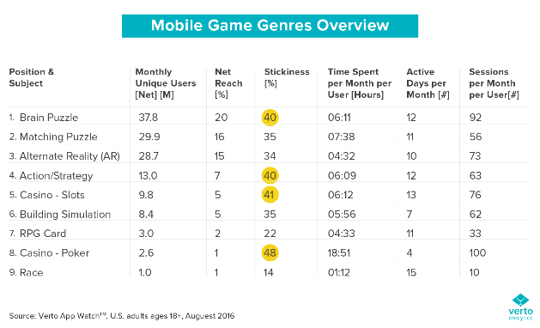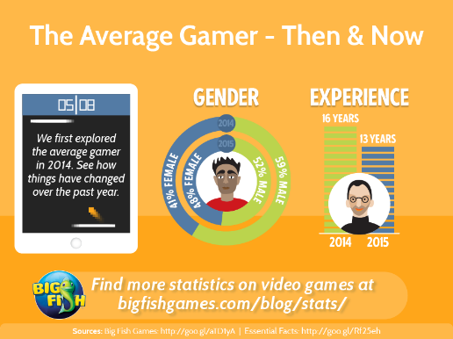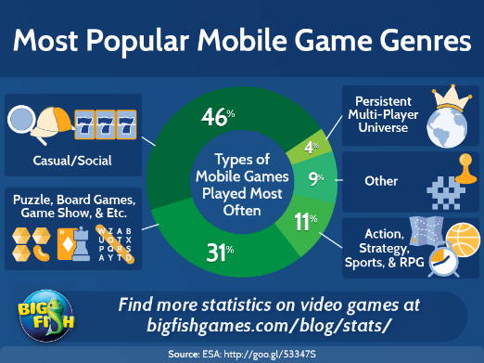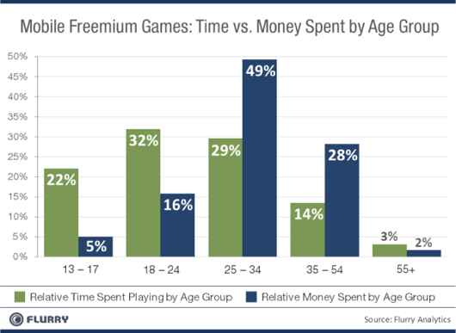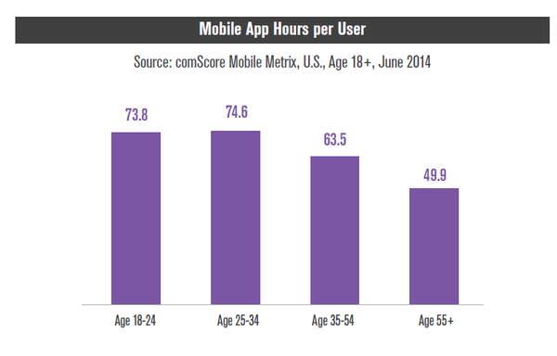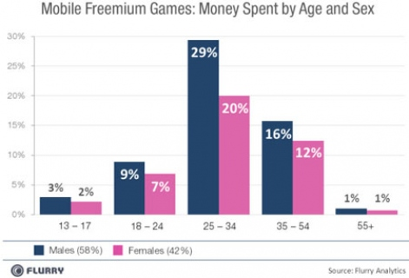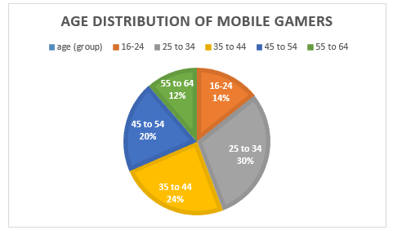

Gathered information from images above

* Women like games that are leaning towards puzzle matching like candy crush saga and men like fighting based games like clash of clans
* 25 to 44 year old male and female mobile gamers have more that 50% of the mobile gamer market.
* All across the globe handheld game applications are player more than twice as much on mobiles than they are on tablets
* Male and female gamers aged 25-34 spend a lot more money on freemium games than any other age group
* Male and female gamers aged 13-17 play games for longer durations of time but do not buy any add ons whereas ages 25-34 play less but buy more.
* The most popular mobile game type worldwide with 46% are casual/social games followed by puzzle/ board games at 31%.

**References towards the demographics of mobile based app games**

* Big Fish Games. (2017). *Most Popular Mobile Game Genres | Big Fish Blog*. [online] Available at: <http://www.bigfishgames.com/blog/stats/most-popular-mobile-game-genres/> [Accessed 27 Oct. 2017].
* Big Fish Games. (2017). *The Average Gamer: Then and Now | Big Fish Blog*. [online] Available at: <https://www.bigfishgames.com/blog/stats/the-average-gamer-then-and-now/> [Accessed 27 Oct. 2017].
* Hwong, C. (2016). *Chart of the Week: Mobile Gamer Demographics - Verto Analytics*. [online] Verto Analytics. Available at: <http://www.vertoanalytics.com/chart-week-mobile-gamer-demographics/> [Accessed 27 Oct. 2017].
* Jordan, J. (2011). *Men out play and out spend women when it comes to mobile freemium gaming says Flurry*. [online] pocketgamer.biz. Available at: <http://www.pocketgamer.biz/news/33480/men-out-play-and-out-spend-women-when-it-comes-to-mobile-freemium-gaming-says-flurry/> [Accessed 27 Oct. 2017].
* Lella, A. (2014). *25-34 Year-Olds are the Heaviest Mobile App Users in U.S.*. [online] comScore, Inc. Available at: <https://www.comscore.com/Insights/Data-Mine/25-34-Year-Olds-are-the-Heaviest-Mobile-App-Users-in-US> [Accessed 27 Oct. 2017].
* Mallory, J. (2011). *Freemium isn't free: 25 to 34 year olds spend the most on extra content*. [online] Engadget. Available at: <https://www.engadget.com/2011/09/10/freemium-isnt-free-25-to-34-year-olds-spend-the-most-on-extra/> [Accessed 27 Oct. 2017].
* RealityMine. (2015). *Myth Busting: Mobile Gaming Demographics from RealityMine*. [online] Available at: <https://www.realitymine.com/myth-busting-mobile-gaming-demographics/> [Accessed 27 Oct. 2017].
* Team, M. (2017). *The 9 Mobile Gaming Statistics That Everyone Should See*. [online] Mediakix | Influencer Marketing Agency. Available at: <http://mediakix.com/2017/05/mobile-gaming-statistics-gaming-apps/#gs.cm=Z5nY> [Accessed 27 Oct. 2017].
* theesa.com. (2014). *Essential Facts About the Computer and Video Game Industry*. [online] Available at: <http://www.theesa.com/wp-content/uploads/2014/10/ESA_EF_2014.pdf> Accessed 27 Oct. 2017].